CS-405-10861-M01 Secure Coding 2024 C-3

5-2 Activity: Encryption Coding

Computer Science Department

Southern New Hampshire University

Eric Farkas

6/9/2024

**Approach Details:**

My approach mostly followed the TODOs throughout the provided source code. The first TODO requires the addition of the key string to the XOR operation. This was accomplished by adding ^ key[i % key_length] to the statement in the sample code. This method requires the source and key strings to be of equal length. The next TODO requires code to load the file data into a string. A try/catch method allows the file to be opened, the data read, and the file to be closed. Best practices require a message to inform the user of the operation failing. The next TODO requires code to format the files when saved. Another try/catch method allows the file to be opened, the student’s name to be written, a timestamp to be added, the key written, the data string written, and the file closed. Best practices require a message to inform the user of the operation failing.

**Console Output:**

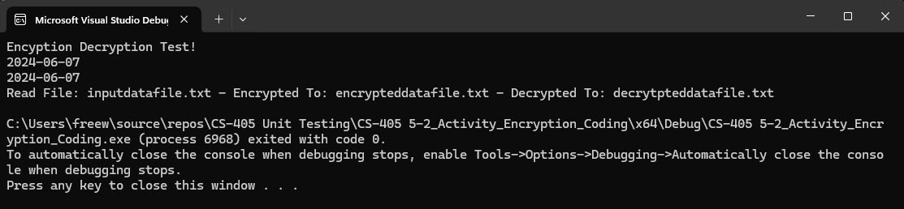

**File Comparison:**

These screen captures allow quick visual comparison of the input and output files. The capture below shows the encrypted file.

